

PROJECT TITLE : STUDENT REPORT CARD

NAME : SHIVAKUMAR

REG NO : RA2111002010033

DEPARTMENT : MECHANICAL

SUBMITTED TO

DR. R. RAJKUMAR

DSBS

SCHOOL OF COMPUTTING

SRMIST

**ABSRACT:**

Student report card system project in C++ is a simple console application built without the use of graphics. In this project, users can perform typical report card related functions like adding a new student record and displaying, modifying, editing and deleting it. File handling has been effectively used to perform all these. This project will teach you how to use file handling in C++, add, read, display, search, modify and delete record from file.

The source code is complete, totally error-free and around 400 lines. I haven’t included the source code for copy/paste here as it is a bit long; you can directly download it from the link below. Also, you can use the description provided here as a general abstract of this project

ile handling has been used for the effective implementation of all the typical features of this project. The key features of Student Report Card System are:

1. **Create student report card record**: This feature creates a new student record containing his marks. For this the information to be provided are the name and roll no. of the student, and the marks obtained by him/her in 5 subjects – Physics, Chemistry, Maths, English and Computer Science.

2. **Read all students report card record**: The *void display_all()* function in this student report card system project in C++ has been used for this feature. It basically shows the progress report of all the students added in file. This feature displays the roll no. and name of all the students, the marks obtained by them in 5 subjects – Physics, Chemistry, Maths, English and Computer Science, along with the percentage and grade of each student.

3. **Read specific student’s report card record**: This feature is same as the one explained above, except it shows the progress report and relevant data related to a particular student.

4. **Display all students’ grade report**: This feature enlists all the students’ record saved in file. The grade report is displayed in a tabular form with roll no. and name of the students, marks achieved in the five subjects, and the grade and percentage obtained by them.

5. **Modify student’s report card record**: In student report card system project in C++, this feature is used to edit the report card record of a particular student. For this, the name and roll no. of the student is sought. Upon successful modification, the program displays the message “Record Updated”. If no record of student is found in file, it displays the message “Record not found”.

6. **Delete student record**: This feature deletes the report card record of a particular student; it first of all asks for the name and roll no. of the student whose record is to be deleted.

**FLOW CHART:**

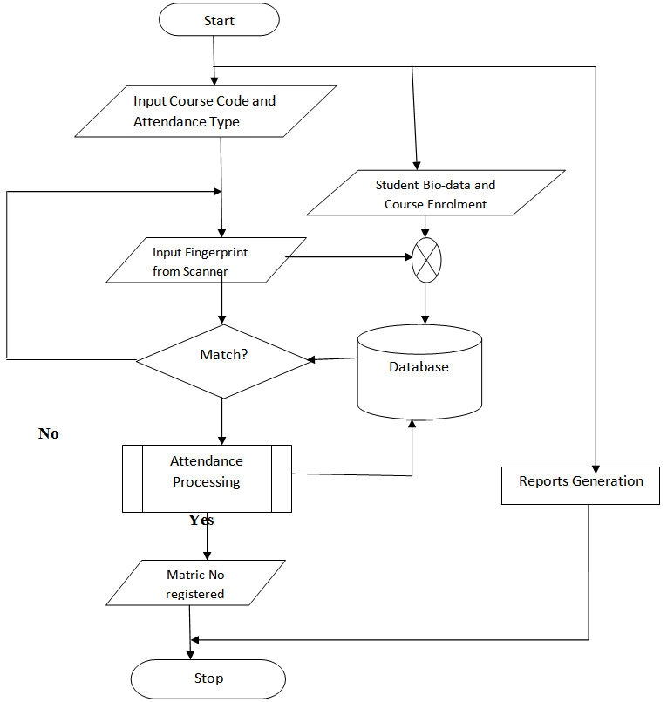

**PROGRAM:**

**#include<conio.h>**

**#include<stdio.h>**

**#include<process.h>**

**struct student**

**{**

**int rollno;**

**char name[50];**

**int p_marks,c_marks,m_marks,e_marks,cs_marks;**

**float per;**

**char grade;**

**int std;**

**}st;**

**FILE *fptr;**

**void write_student()**

**{**

**fptr=fopen("student.dat","ab");**

**printf("\nPlease Enter The New Details of student \n");**

**printf("\nEnter The roll number of student ");**

**scanf("%d",&st.rollno);**

**fflush(stdin);**

**printf("\n\nEnter The Name of student ");**

**gets(st.name);**

**printf("\nEnter The marks in physics out of 100 : ");**

**scanf("%d",&st.p_marks);**

**printf("\nEnter The marks in chemistry out of 100 : ");**

**scanf("%d",&st.c_marks);**

**printf("\nEnter The marks in maths out of 100 : ");**

**scanf("%d",&st.m_marks);**

**printf("\nEnter The marks in english out of 100 : ");**

**scanf("%d",&st.e_marks);**

**printf("\nEnter The marks in computer science out of 100 : ");**

**scanf("%d",&st.cs_marks);**

**st.per=(st.p_marks+st.c_marks+st.m_marks+st.e_marks+st.cs_marks)/5.0;**

**if(st.per>=60)**

**st.grade='A';**

**else if(st.per>=50 &&st.per<60)**

**st.grade='B';**

**else if(st.per>=33 &&st.per<50)**

**st.grade='C';**

**else**

**st.grade='F';**

**fwrite(&st,sizeof(st),1,fptr);**

**fclose(fptr);**

**printf("\n\nStudent Record Has Been Created ");**

**getch();**

**}**

**void display_all()**

**{**

**clrscr();**

**printf("\n\n\n\t\tDISPLAY ALL RECORD !!!\n\n");**

**fptr=fopen("student.dat","rb");**

**while((fread(&st,sizeof(st),1,fptr))>0)**

**{**

**printf("\nRoll Number of Student : %d",st.rollno);**

**printf("\nName of student : %s",st.name);**

**printf("\nMarks in Physics : %d",st.p_marks);**

**printf("\nMarks in Chemistry : %d",st.c_marks);**

**printf("\nMarks in Maths : %d",st.m_marks);**

**printf("\nMarks in English : %d",st.e_marks);**

**printf("\nMarks in Computer Science : %d",st.cs_marks);**

**printf("\nPercentage of student is : %.2f",st.per);**

**printf("\nGrade of student is : %c",st.grade);**

**printf("\n\n====================================\n");**

**getch();**

**}**

**fclose(fptr);**

**getch();**

**}**

**void display_sp(int n)**

**{**

**int flag=0;**

**fptr=fopen("student.dat","rb");**

**while((fread(&st,sizeof(st),1,fptr))>0)**

**{**

**if(st.rollno==n)**

**{**

**clrscr();**

**printf("\nRoll number of student : %d",st.rollno);**

**printf("\nName of student : %s",st.name);**

**printf("\nMarks in Physics : %d",st.p_marks);**

**printf("\nMarks in Chemistry : %d",st.c_marks);**

**printf("\nMarks in Maths : %d",st.m_marks);**

**printf("\nMarks in English : %d",st.e_marks);**

**printf("\nMarks in Computer Science : %d",st.cs_marks);**

**printf("\nPercentage of student is : %.2f",st.per);**

**printf("\nGrade of student is : %c",st.grade);**

**flag=1;**

**}**

**}**

**fclose(fptr);**

**if(flag==0)**

**printf("\n\nrecord not exist");**

**getch();**

**}**

**void modify_student()**

**{**

**int no,found=0;**

**clrscr();**

**printf("\n\n\tTo Modify ");**

**printf("\n\n\tPlease Enter The roll number of student");**

**scanf("%d",&no);**

**fptr=fopen("student.dat","rb+");**

**while((fread(&st,sizeof(st),1,fptr))>0 && found==0)**

**{**

**if(st.rollno==no)**

**{**

**printf("\nRoll number of student : %d",st.rollno);**

**printf("\nName of student : %s",st.name);**

**printf("\nMarks in Physics : %d",st.p_marks);**

**printf("\nMarks in Chemistry : %d",st.c_marks);**

**printf("\nMarks in Maths : %d",st.m_marks);**

**printf("\nMarks in English : %d",st.e_marks);**

**printf("\nMarks in Computer Science : %d",st.cs_marks);**

**printf("\nPercentage of student is : %.2f",st.per);**

**printf("\nGrade of student is : %c",st.grade);**

**printf("\nPlease Enter The New Details of student \n");**

**printf("\nEnter The roll number of student ");**

**scanf("%d",&st.rollno);**

**fflush(stdin);**

**printf("\n\nEnter The Name of student ");**

**gets(st.name);**

**printf("\nEnter The marks in physics out of 100 : ");**

**scanf("%d",&st.p_marks);**

**printf("\nEnter The marks in chemistry out of 100 : ");**

**scanf("%d",&st.c_marks);**

**printf("\nEnter The marks in maths out of 100 : ");**

**scanf("%d",&st.m_marks);**

**printf("\nEnter The marks in english out of 100 : ");**

**scanf("%d",&st.e_marks);**

**printf("\nEnter The marks in computer science out of 100 : ");**

**scanf("%d",&st.cs_marks);**

**st.per=(st.p_marks+st.c_marks+st.m_marks+st.e_marks+st.cs_marks)/5.0;**

**if(st.per>=60)**

**st.grade='A';**

**else if(st.per>=50 && st.per<60)**

**st.grade='B';**

**else if(st.per>=33 && st.per<50)**

**st.grade='C';**

**else**

**st.grade='F';**

**fseek(fptr,-(long)sizeof(st),1);**

**fwrite(&st,sizeof(st),1,fptr);**

**printf("\n\n\t Record Updated");**

**found=1;**

**}**

**}**

**fclose(fptr);**

**if(found==0)**

**printf("\n\n Record Not Found ");**

**getch();**

**}**

**void delete_student()**

**{**

**int no;**

**FILE *fptr2;**

**clrscr();**

**printf("\n\n\n\tDelete Record");**

**printf("\n\nPlease Enter The roll number of student You Want To Delete");**

**scanf("%d",&no);**

**fptr=fopen("student.dat","rb");**

**fptr2=fopen("Temp.dat","wb");**

**rewind(fptr);**

**while((fread(&st,sizeof(st),1,fptr))>0)**

**{**

**if(st.rollno!=no)**

**{**

**fwrite(&st,sizeof(st),1,fptr2);**

**}**

**}**

**fclose(fptr2);**

**fclose(fptr);**

**remove("student.dat");**

**rename("Temp.dat","student.dat");**

**printf("\n\n\tRecord Deleted ..");**

**getch();**

**}**

**void class_result()**

**{**

**clrscr();**

**fptr=fopen("student.dat","rb");**

**if(fptr==NULL)**

**{**

**printf("ERROR!!! FILE COULD NOT BE OPEN\n\n\n Go To Entry Menu to create File");**

**printf("\n\n\n Program is closing ....");**

**getch();**

**exit(0);**

**}**

**printf("\n\n\t\tALL STUDENTS RESULT \n\n");**

**printf("====================================================\n");**

**printf("R.No. Name P C M E CS %age Grade\n");**

**printf("====================================================\n");**

**while((fread(&st,sizeof(st),1,fptr))>0)**

**{**

**printf("%-6d %-10s %-3d %-3d %-3d %-3d %-3d %-3.2f %-1c\n",st.rollno,st.name,st.p_marks,st.c_marks,st.m_marks,st.e_marks,st.cs_marks,st.per,st.grade);**

**}**

**fclose(fptr);**

**getch();**

**}**

**void result()**

**{**

**int ans,rno;**

**char ch;**

**clrscr();**

**printf("\n\n\nRESULT MENU");**

**printf("\n\n\n1. Class Result\n\n2. Student Report Card\n\n3.Back to Main Menu");**

**printf("\n\n\nEnter Choice (1/2)? ");**

**scanf("%d",&ans);**

**switch(ans)**

**{**

**case 1 : class_result();break;**

**case 2 : {**

**do{**

**char ans;**

**clrscr();**

**printf("\n\nEnter Roll Number Of Student : ");**

**scanf("%d",&rno);**

**display_sp(rno);**

**printf("\n\nDo you want to See More Result (y/n)?");**

**scanf("%c",&ans);**

**}while(ans=='y'||ans=='Y');**

**break;**

**}**

**case 3: break;**

**default: printf("\a");**

**}**

**}**

**void intro()**

**{**

**clrscr();**

**gotoxy(35,11);**

**printf("STUDENT");**

**gotoxy(33,14);**

**printf("REPORT CARD");**

**gotoxy(35,17);**

**printf("PROJECT");**

**printf("\n\n\n\n\n\nMADE BY : SULABH AGRAWAL");**

**printf("\n\nCOLLEGE : ASN ENGINEERING COLLEGE");**

**getch();**

**}**

**void entry_menu()**

**{**

**char ch2;**

**clrscr();**

**printf("\n\n\n\tENTRY MENU");**

**printf("\n\n\t1.CREATE STUDENT RECORD");**

**printf("\n\n\t2.DISPLAY ALL STUDENTS RECORDS");**

**printf("\n\n\t3.SEARCH STUDENT RECORD ");**

**printf("\n\n\t4.MODIFY STUDENT RECORD");**

**printf("\n\n\t5.DELETE STUDENT RECORD");**

**printf("\n\n\t6.BACK TO MAIN MENU");**

**printf("\n\n\tPlease Enter Your Choice (1-6) ");**

**ch2=getche();**

**switch(ch2)**

**{**

**case '1': clrscr();**

**write_student();**

**break;**

**case '2': display_all();break;**

**case '3': {**

**int num;**

**clrscr();**

**printf("\n\n\tPlease Enter The roll number ");**

**scanf("%d",&num);**

**display_sp(num);**

**}**

**break;**

**case '4': modify_student();break;**

**case '5': delete_student();break;**

**case '6': break;**

**default:printf("\a");entry_menu();**

**}**

**}**

**void main()**

**{**

**char ch;**

**intro();**

**do**

**{**

**clrscr();**

**printf("\n\n\n\tMAIN MENU");**

**printf("\n\n\t01. RESULT MENU");**

**printf("\n\n\t02. ENTRY/EDIT MENU");**

**printf("\n\n\t03. EXIT");**

**printf("\n\n\tPlease Select Your Option (1-3) ");**

**ch=getche();**

**switch(ch)**

**{**

**case '1': clrscr();**

**result();**

**break;**

**case '2': entry_menu();**

**break;**

**case '3':exit(0);**

**default :printf("\a");**

**}**

**}while(ch!='3');**

**}**

**RESULT:**

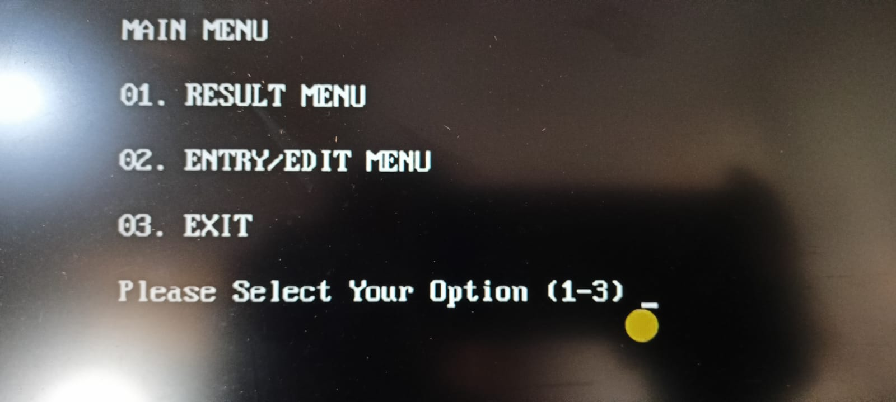

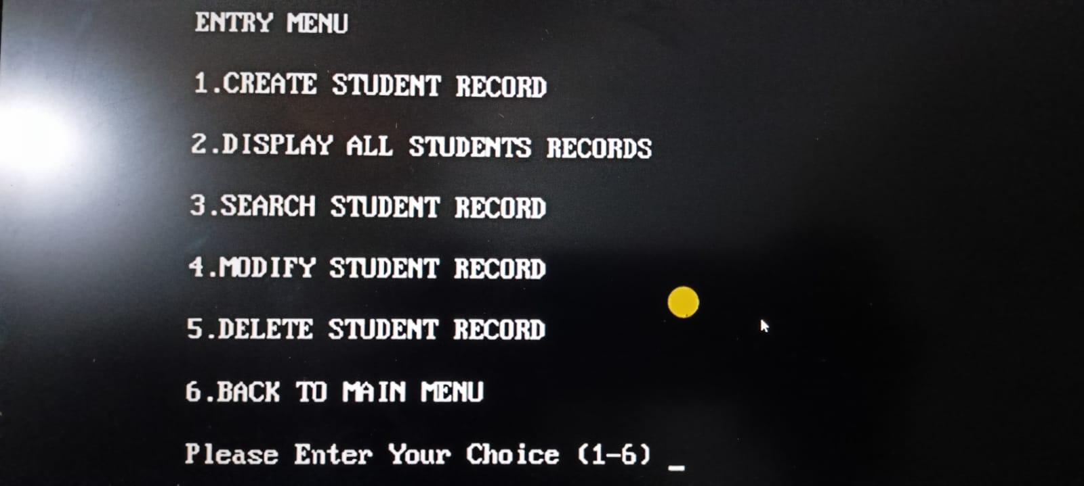

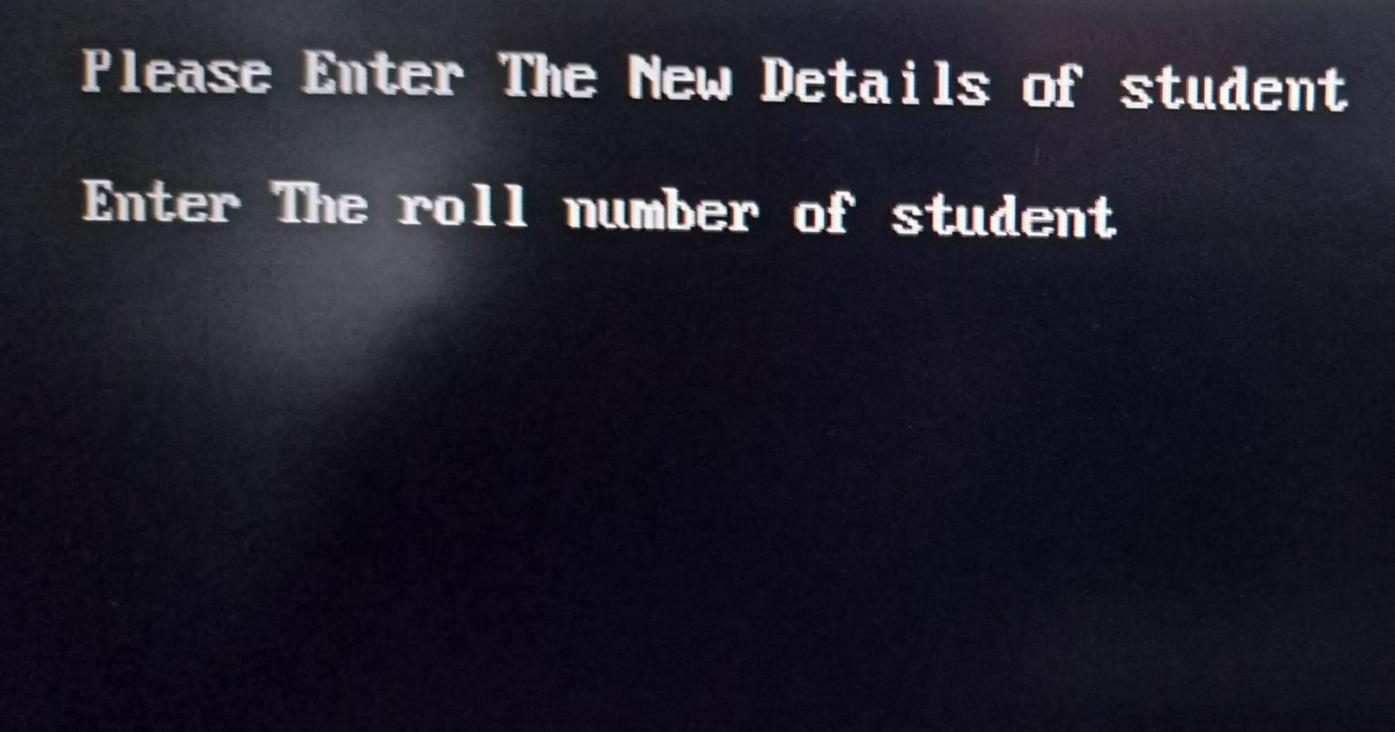

**DECLARATION :**

I would like to thank my PPS Faculty Dr.R.Rajkumar,who gave me this opportunity to work on this project. I got to learn a lot from this project about . I would also like to thank department of computing for giving this project

At last, I would like to extend my heartfelt thanks to my parents because without their help this project would not have been successful. Finally, I would like to thank my dear friends who have been with me all the time.

**REFERENCES:**

https://github.com/yasirwahid/C-C-projects/blob/master/Student-Report...